


LAB WEEK 7
  - SEP 2026 SEMESTER

‘AFFAN NAJIY BIN RUSDI
22010453
BACHELOR OF COMPUTER SCIENCE
MODELING AND SIMULATION
TEB2103

Contents
Activity 3
Activity 1: Number Generator 3
Activity 2: Weather Generator 4
Activity 3: Machine Operation 5
Mini Challenge: Queue Simulation Generator 6
Mini Project 8
Traffic Light System 8

Activity

Activity 1: Number Generator
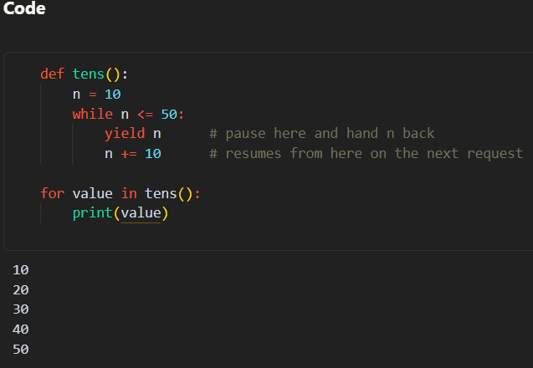

Explanation
Firstly, a generator called `tens()` was created, where `n` starts at 10. Each `yield n` hands back the current value and pauses the function. When the next value is requested, it continues from where it stopped and adds 10 to `n`. Once `n` reaches 60, the `while` condition becomes false, so the function ends and the `for` loop stops on its own through `StopIteration`. This is similar to a bank queue number machine, which only prints the next number when the button is pressed.

Code
def tens():
n = 10
while n <= 50:
yield n # pause here and hand n back
n += 10 # resumes from here on the next request

for value in tens():
print(value)

Activity 2: Weather Generator
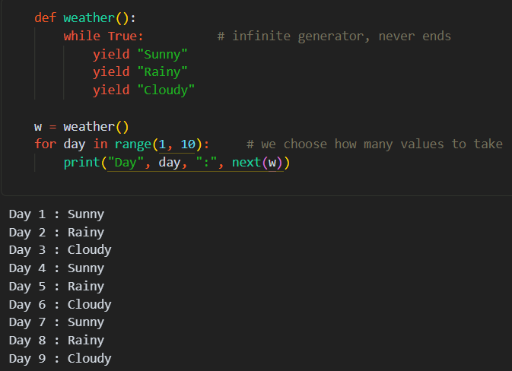

Explanation
Secondly, a weather generator was created using `while True`, which makes it an infinite generator, meaning it never runs out of values. It yields Sunny, Rainy and Cloudy, then starts again from Sunny, so the weather repeats continuously. The program does not freeze, because a generator only runs when the next value is requested. However, looping over it with `for x in weather():` would never end. Hence, `next(w)` was only called 9 times to display three full cycles, while the generator itself can continue forever.

Code
def weather():
while True: # infinite generator, never ends
yield "Sunny"
yield "Rainy"
yield "Cloudy"

w = weather()
for day in range(1, 10): # we choose how many values to take
print("Day", day, ":", next(w))

Activity 3: Machine Operation
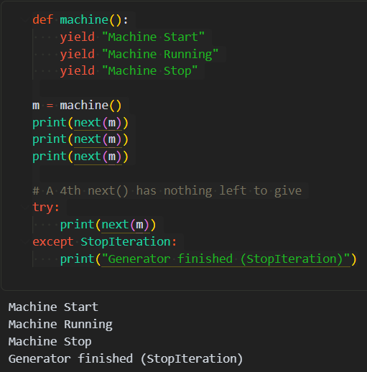

Explanation
Thirdly, a machine generator with exactly three `yield` statements was created, which makes it a finite generator. Each `next(m)` moves the machine from Start to Running to Stop, much like a washing machine cycle. A fourth `next(m)` raised `StopIteration`, which is the error Python uses to signal that a generator is finished. A `for` loop catches this error automatically, but calling `next()` by hand does not, so it was handled with a `try` block.

Code
def machine():
yield "Machine Start"
yield "Machine Running"
yield "Machine Stop"

m = machine()
print(next(m))
print(next(m))
print(next(m))

# A 4th next() has nothing left to give
try:
print(next(m))
except StopIteration:
print("Generator finished (StopIteration)")

Mini Challenge: Queue Simulation Generator
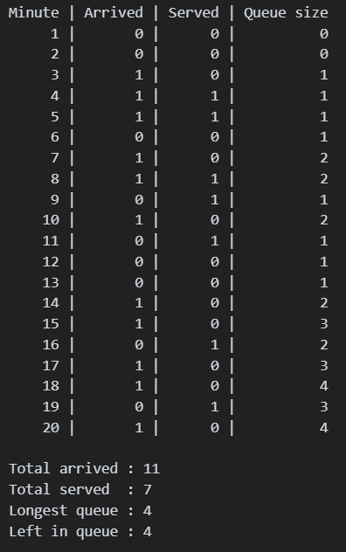

Explanation
The original code only adds customers, so the queue can only grow. Hence, customer service was added, whereby each minute one customer is served with a 50% chance, but only if `q > 0`, so the queue never becomes negative. The generator yields the minute, arrival, service and queue size, and runs for 20 minutes instead of 10. In this run, 11 customers arrived and 7 were served, leaving 4 in the queue, similar to a cafe at lunch hour. `random.seed(1)` keeps the result the same every run.

Code
import random

def queue(minutes=20):
q = 0
for minute in range(1, minutes + 1):
arrival = random.randint(0, 1) # 1 = a customer arrives this minute
if arrival == 1:
q += 1

served = 0
if q > 0 and random.randint(0, 1) == 1: # can only serve if someone is waiting
q -= 1
served = 1

yield minute, arrival, served, q

random.seed(1) # optional: fixes the random numbers so the result is repeatable

total_arrived = total_served = max_q = 0
print("Minute | Arrived | Served | Queue size")
for minute, arrived, served, size in queue(20):
print(f"{minute:6} | {arrived:7} | {served:6} | {size:10}")
total_arrived += arrived
total_served += served
max_q = max(max_q, size)

print("\nTotal arrived :", total_arrived)
print("Total served :", total_served)
print("Longest queue :", max_q)
print("Left in queue :", total_arrived - total_served)

Mini Project

Traffic Light System
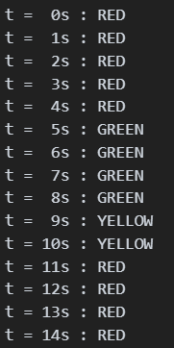

Explanation
Firstly, the traffic light from Example 3 was improved by giving each light a duration, whereby RED lasts 5 seconds, GREEN 4 seconds and YELLOW 2 seconds. The outer `while True` loop repeats the cycle forever, while the inner loops count the seconds and yield the time and colour once per second. As a result, one cycle takes 11 seconds, so the light turns RED again at t = 11. This is closer to a real junction, as opposed to the lab example where each colour only lasts one step.

Code
def traffic_light():
durations = {"RED": 5, "GREEN": 4, "YELLOW": 2} # seconds each light stays on
t = 0
while True:
for colour in ["RED", "GREEN", "YELLOW"]:
for _ in range(durations[colour]):
yield t, colour
t += 1

light = traffic_light()
for _ in range(15):
t, colour = next(light)
print(f"t = {t:2}s : {colour}")



